T. HARRY GARRETT
ELEMENTARY SCHOOL



2024-2025
STUDENT-PARENT
HANDBOOK

Ms. Stacey M. Walk, Principal

Dr. Chantell Scott, Assistant Principal

1100 Eisenhower Drive

Augusta, GA 30904

Phone: (706) 737-7222| Fax: (706)-737-1166
STUDENT-PARENT HANDBOOK
2024-2025

WELCOME

Welcome to T. Harry Garrett Elementary School. Your child is entering one of the finest elementary schools in Richmond County Our faculty and staff are dedicated to academic excellence and creativity in the arts, and we would like to encourage our parents/guardians to be active in their child’s education. It is only when both our parents/guardians and faculty/staff work together that your child will experience the true joy of learning and be successful in their endeavors.

This handbook has been prepared to help you understand some of the policies and practices of our school and to acquaint you with our Arts Infusion Program. I hope that you will find all the information that you need to help your child be successful at Garrett.

My personal vision is that T. Harry Garrett will become a world-class educational institution where students will increase in their academic achievements and creative expression while continuing to focus on our commitment to our local community. With your continued support, I know that we will attain this goal!

Ms. Stacey M. Walk
Principal
T. Harry Garrett Elementary

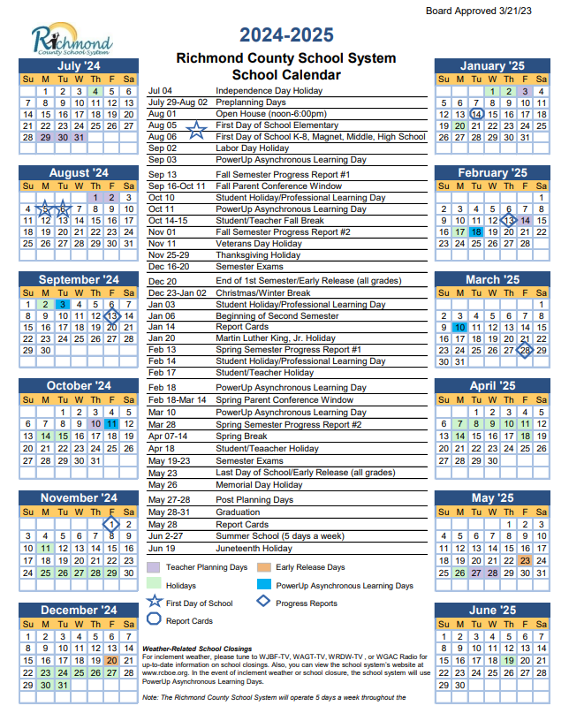

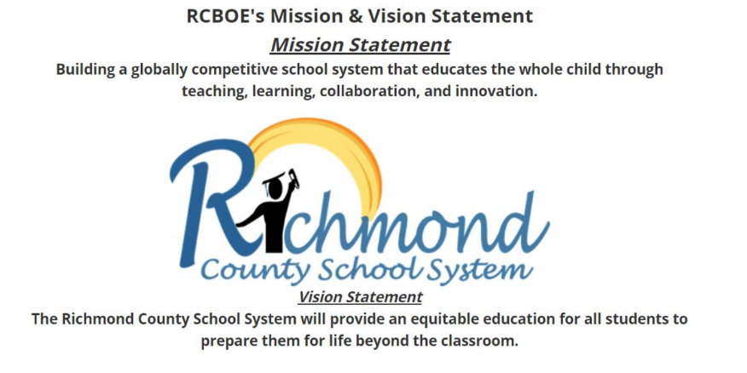

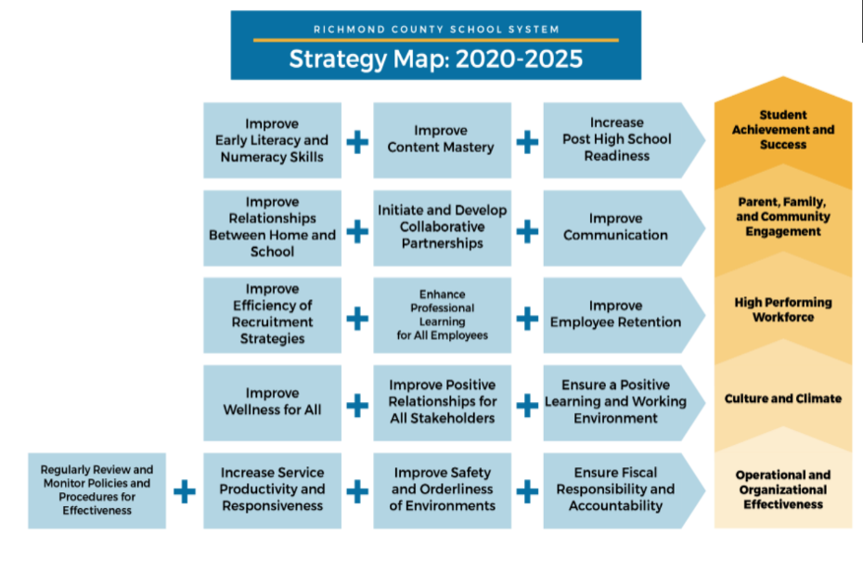

Listed below are the phone numbers to the school and county offices.

Office 706-737-7222

Lunchroom 706-737-7222 Ext. 1714

Media Center 706-737-7222 Ext. 1712

Curriculum 706-826-1102
Food Services 706-826-1122

District Office 706-826-1000

Gym 706-821-1776

Transportation 706-796-4777

Psychological Services 706-826-1131

Special Education 706-826-1132

OUR MISSION STATEMENT

Garrett Elementary will increase academic achievement using STEAM curriculum providing an equitable education for all students to prepare them for life beyond the classroom.

OUR VISION

Increasing academic achievement for all students in a globally competitive environment that educates the whole child through STEAM teaching, learning, collaboration, and innovation.

PHILOSOPHY AND OBJECTIVES

The philosophy of T. Harry Garrett Elementary School is to guide each individual student to attain his/her inherent potential emotionally, socially, intellectually, physically and aesthetically. Each student should be given opportunities to choose between right and wrong understand the rewards or consequences of the choices and be able to accept student’s understanding, appreciation, and development of skills necessary for growth in our democratic culture. The program should include enjoyable learning activities and flexibility.

Each student should receive basic skills in each of the following areas: Language Arts, Mathematics, Science, Social Studies, Fine Arts, and the latest technology in order to be a more productive citizen. Cognitive and affective skills will be taught so the student will have the opportunity to develop critical thinking skills.

Parents should be informed of student progress through conferences with students, parents, teachers, and administrators. This should encourage responsibility and involvement.

The faculty and staff should continuously keep abreast of and utilize current professional techniques. Garrett teachers are encouraged to be innovative and think ‘outside of the box,’ to utilize ‘best practices’ in schools, and to collaborate with other teachers and peers not only at our institution but to seek excellence in other places as well.

We believe that each student is special and important: therefore, he/she has the right to all the help he/she needs. Each student has something to contribute to our society. It is our job, as educators, to enhance those contributions so that they might have a positive effect on others.

OUR BELIEFS

We believe:

- That all students will learn when engaged in excellent, well-prepared lessons.

- Each student is a valued individual with unique physical, social, emotional intellectual needs.

- Teamwork and collaboration is essential for success.

- Teachers, administrators, parents and the community share the responsibility for advancing the school’s missions.

- Learning/teaching is exciting.

- A variety of activities must be incorporated to accommodate differences in learning styles and rates of learning.

- Assessment of student learning should provide students with a variety of opportunities to demonstrate their achievement of their learning and provide data for feedback to parents, teachers and the community.

- Respect for self, others, and the community must be honored.

THE SCHOOL DAY

Hours of Operation

School Office Hours
The front office is open on Monday-Friday 7:00am-3:00pm.

Instructional Day
The instructional day for students is from 7:25am - 2:15pm.

Students are not to enter the building nor be left at school unattended before 7:00a.m. or after 2:15p.m.

Teacher Work Day
Teachers work from 7:00am-2:30pm. However, all meetings and professional learning may begin as early as 2:30p.m., or immediately after students are dismissed at 2:15p.m.

Arrival and Dismissal

Morning Arrival
The earliest your child can be dropped off in the morning is 7:00 a.m. There is no one to supervise your child before that time, and it is unlawful for you to leave your child unsupervised at a public facility. No students are allowed to sit on the benches to wait for the doors to open unless there is a parent with him/her. Supervising teachers start their duty at 7:00 am every morning, so please wait until they are on duty before you release your child. This rule is solely for the protection of your children!

In the morning, the only students who should be dropped off in front of the school are bus riders, daycare, and cars with students who have a special badge that lets school staff know that they can be dropped off in front of the building.

Parents please follow the direction of the staff during student drop-off and pick-up to avoid issues and delays with arrival and dismissal. Also, please do not stop/drop off in a manner that will block morning or afternoon traffic flow. Parents are not permitted to park, drop off, or pick up students in the bus loading/van area. This interferes with bus arrival and dismissal.

The latest your child should report to school is 7:25 am. Any child entering the classroom after 7:25 a.m. is considered tardy. Your help is needed since your child is held responsible for being on time. Any student arriving to school after 7:25 a.m. must be signed in by a parent.

7:00-7:25 am is NOT a good time to talk with a teacher–she/he is either on duty or preparing for class. Please plan to discuss your child/share information at a time when the teacher does not have any students (and after these times) – email, send a note, or call and your child’s teacher will be happy to talk with you during one of his/her free times or after students are dismissed.

Our lunchroom will serve breakfast each morning from 7:00 a.m. -7:25 a.m. All students are allowed to eat a free breakfast.

If you have items that need to go to the classroom, please drop them off at the office—we’ll be sure they get to the classroom.

Afternoon Dismissal

1:30 p.m.-Pre-K Dismissal and Pre-K Siblings
1:50 p.m.-Boys & Girls Club, Kindergarten Car Riders/Walkers, Daycare Vans
1:55 p.m.-1st-3rd Grade Car Riders/Walkers
2:00 p.m.-4th - 5th Grade Car Riders/Walkers
2:15 p.m. – Bus Riders, Walkers/Loud Crowd and Prime Time

Bus are called when buses arrives at school.
- Please do not block bus and van lanes in front of the school during afternoon pickup.
- Parents that park to get students should park in gym area.
- Car Line is on the side of the building with the covered awnings. Do not park and get out of car, it endangers your child.

Remember to drive slowly on campus and obey school speed limits. Speeding and/or other safety violations will result in a warning; next incident will be reported to RCBOE Public Safety.

All students are expected to be out of the building by 2:15p.m. Faculty meetings and teacher
planning begin as early as 2:30 pm or immediately after students are dismissed at 2:15p.m.

TRANSPORTATION

Please refrain from calling the school office to make transportation arrangements. Transportation changes must be provided to the school office in written form. Written, signed notes may be sent with the student, faxed, or emailed before 1:30 p.m. If a written, signed note is not received and no emergency change has been approved, the student will go home the regularly scheduled way. Telephone calls will not be accepted except in case of extreme emergencies after 1:30pm in order to prepare for dismissal. In case of an emergency, parents/guardians must speak with an administrator. Our students are young and may get confused with multiple forms of transportation. Please try to maintain a set method of transportation. Students may not be removed from buses after they are loaded or have left the school.

Telephone Calls
The school telephones are not available for student use except in case of an emergency.
Car Rider & Bus Rider Tags
Parents/guardians who pick their child up from school in the afternoons should follow the direction of
staff for a smooth and safe dismissal. If car rider Car Rider tags are provided, please displayed in the
front windshield on the passenger side of the vehicle. All students in grade K-3 will receive a bus
tag to attach to their book bags for the first 2 weeks of school. The tags will include the child’s
name, bus number and parent contact information. Please be sure students LEAVE THE TAGS
ATTACHED TO THEIR BOOK BAGS, in an effort to better ensure students leave school provided the proper form of transportation and GET HOME SAFELY.

Transportation

Riding a school bus is a privilege extended to students and can be taken away for disruptive, unsafe, or unsatisfactory conduct. Bus misbehavior can be distracting to the driver, therefore dangerous, and will not be tolerated. Bus drivers are the first line of interaction with students. Bus drivers will be expected to utilize behavior management techniques on the bus. These include verbal and written warnings along with assigned seating. Principal assistance will be used as necessary. These rules will help your child understand correct behavior.

SCHOOL BUS RULES AND PUPLIC RESPONSIBILITIES

- The driver is in charge of the bus and all public aboard. Obey the driver promptly and cheerfully.
- Obey and respect the order of the authorized persons.
- Be on time; the driver cannot wait beyond his/her regular schedule for those who are tardy.
- Wait in an orderly line off the street or road.
- Ride only the bus assigned by school officials.
- Cross in front of the bus only when the road is clear and at a safe distance in front of the bus in order to be seen by the driver. (Minimum: 10 feet)
- Do not run toward a school bus while it is in motion.
- Do not try to get on or off the bus or move about within the bus while it is in motion.
- Pupils must occupy seats assigned to them by the bus driver or school officials and remain seated while the bus is moving. Ride three in a seat if necessary and do not exchange seats unless given permission by the driver. If all seats are taken, stand to the rear of the white marker line when the bus is in motion.
- Behave on the bus as you are expected to behave in the classroom. Insolence, disobedience, vulgarity, foul language, fighting, pushing, and similar offensive acts will not be tolerated.
- Do not engage in any activity which might divert the driver’s attention, such as:
- Loud talking or laughing or unnecessary confusion.
- Unnecessary conversation with the driver.
- Extending any parts of the body out of the bus windows, or doors, or riding outside the bus.
- Pupils, must not open or close bus windows without permission of the driver nor shall they regulate or operate any part of the bus.
- Do not engage in any activity which might damage, cause excessive wear or litter to the bus or other property. The following activities are prohibited at all times:
- Smoking or eating on the bus.
- Spitting or throwing anything in or from the bus.
- Possessing knives or sharp objects on the bus.
- Bringing animals on the bus.
- Tampering with mechanical equipment, accessories, or controls on the bus.
- Pupils must be courteous to the driver, to fellow students and to passers-by.
- Pupils will not leave the bus on the way to school or home without permission of the driver. Drivers will not give permission except in case of personal emergency or upon request of the principal or pupil’s parent.
- Report promptly to the driver any damage done to the bus. Persons causing damage shall be expected to defray its full cost

School Bus Regulations
Students are under the supervision of bus drivers and should heed their direction(s). Improper conduct on the bus or at the bus stop can result in that privilege being revoked. Reported acts of misconduct on the bus may be investigated. Copies of bus rules are available as needed.
Fighting Typical procedures are as follows:
1st Report: Verbal Warning / Letter sent home to be signed and returned.
2nd Report: Written Warning Letter and Call by an Administrator to Parents. Conference may be required before child can return to bus.
3rd Report: 3 Days SUSPENSION from bus
4th Report: 5-10 Days SUSPENSION from bus
5th Report: Conference required with bus driver and administrator to determine future bus
privileges. Parent attendance is necessary.
6th offense: Expulsion from bus for the remainder of the school year

***If the administrator determines that an offense is serious enough, ex: fighting on bus, etc,
suspension may result immediately and possibly indefinitely.***

ATTENDANCE LAW & POLICIES

Research shows that the single greatest factor contributing to student achievement is attendance in school. While a student who is absent may be able to cover a missed chapter, copy missed notes, or complete some written assignments, other very important aspects of a lesson are gone forever. Discussion, listening, note taking, raised questions, explanations, and clarifications are among the important interactions that are irretrievably lost despite the sincerest and unavoidable attempts to regain those components of the lesson.

GEORGIA COMPULSORY ATTENDANCE LAW
Any parent, guardian, or other person residing in Georgia who has control or charge of a child or children between the ages of 6 and 16 years of age and any child residing in Georgia and in Richmond County between the ages of 6 and 16 years of age is required under Georgia law to enroll and attend school. Under the provisions of Georgia’s Compulsory Attendance Act, each day’s absence from school after a student has accumulated five (5) days of unexcused absence, whether consecutive or not, can constitute a violation of the law and can subject the parent and student to penalties which may include a fine of not less than Twenty-Five Dollars ($25.00) and not greater than One Hundred Dollars ($100.00), imprisonment not to exceed thirty (30) days, community service, court supervisor as a juvenile offender, or any combination of these penalties. For detailed information regarding attendance, please refer to the RCSS Code of Student Conduct and Discipline.

ABSENCES
Regular, punctual attendance is extremely important for school success. Students are expected to be present for school. Students arriving before 10:30 a.m. will be counted present but tardy. Students checking out before 10:30 a.m. or arriving after 10:30 a.m. will be considered absent. A student’s yearly attendance is recorded as part of his/her permanent school record. In the event of an absence, a note from a parent/guardian explaining the reason for absence is required for each absence in order to possibly excuse the absence. This note, signed by the parent, should be submitted to the homeroom teacher upon the student’s return to school. The student is responsible for all make-up assignments within five (5) days if credit is desired. In cases of unexcused absences, the student may not be given make-up work. The only excusable absences are those prescribed by state statutes, rules and regulations of the Department of Education and local board policy. Guidelines for lawful excuses and extended absences are listed in the Richmond County Student Code of Conduct and Discipline. Also, please reference the RCSS Attendance Protocol below.

Regular, punctual attendance is extremely important for school success. Early sign-outs should be
limited to doctor or dental appointments or other unavoidable obligations. A student’s yearly attendance is recorded as part of his/her permanent school record. When your child is absent, please send a note (from parent or doctor) with the child upon his/her return to school. Teachers are not required to allow makeup work for unexcused absences or frequent tardies. ***Many incentives will be in place for good attendance such as attendance parties, perfect attendance certificates, public recognition, prizes, etc.

TARDIES
Students who arrive at school after 7:25 a.m. will be counted as tardy. Tardy students must report to the office to check in and receive a Tardy Slip in order to be admitted to class. Parents/guardians must accompany students when they are tardy and parents/guardians must sign in their child(ren).

Special Notes: Tardies and/or Early Dismissals on 10 or more days will disqualify a student for
yearly Perfect Attendance awards, as 10 tardies = 1 absence.

EARLY DISMISSAL PROCEDURES/EARLY RELEASE
When a student needs to be signed out before the regularly scheduled dismissal time, parents/guardians must come into the office, sign the student out on the computer at the front desk, and the student will be called to the office for dismissal. Students will not be called to the office ahead of time so they can “be ready” when the parent/guardian arrives. Students will not be sent out to vehicles. Early dismissals count as tardies as part of the attendance protocol. Students will not be released after 1:30pm daily (teachers and students are preparing to get in place for dismissal), nor released to anyone other than the parent or guardian or other authorized person(s) noted on registration paperwork and/or as noted in infinite campus per parent/guardian written notice/documents. Parents or guardians must send documentation to school for absences to be excused. Your child’s academic success may be jeopardized if he/she is consistently signed out
before 2:15pm. On Early Release days, Garrett Elementary will release students at 12:00 pm. See the 2024-2025 school calendar for dates.
EMERGENCY CONTACT INFORMATION
It is critical for the school to know where parents work, how to reach them or who to call in the case of an emergency. Any change in the status of the contact information should be reported to the child’s teacher or the school office as soon as change occurs. ** At least one (1) emergency telephone number is REQUIRED for every student.

RCSS Attendance Protocol

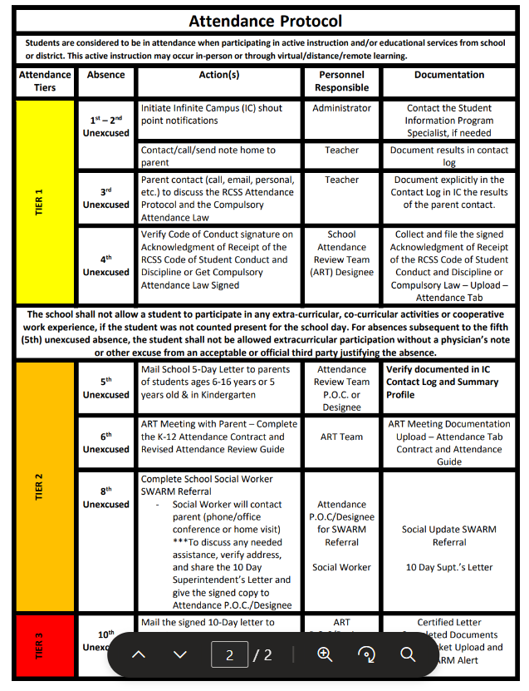

PARENTAL INVOLVEMENT
This Code of Conduct is based on the expectation that parents, guardians, teachers and school administrators will work together to improve and enhance student behavior and academic performance and will communicate freely their concerns about, and actions in response to, student behavior that detracts from the learning environment. School administrators recognize that two-way communication through personal contacts is extremely valuable; therefore, they provide information to parents as well as on-going opportunities for school personnel to hear parents’ concerns and comments.
The Code of Conduct specifies within its standards of behavior various violations of the Code, which may result in a school staff member’s request that, a parent or guardian come to the school for a conference. Parents are encouraged to visit the schools regularly, adhere to the policy below, and are expected to be actively involved in the behavior support processes designed to promote positive choices and behavior.
Georgia law also provides that, under certain circumstances, a teacher has the authority to remove a student whose behavior is in violation of the student code of conduct from his or her classroom if the student repeatedly or substantially interferes with the teacher’s ability to communicate effectively with the students in the class, with the ability of the student’s classmates to learn, or if the student poses an immediate threat to the student’s classmates or the teacher. The procedure is detailed in local policy and state law.
Georgia law mandates that any time a teacher or principal identifies a student as a chronic disciplinary problem student, the principal shall notify by telephone call and by mail the student’s parent or guardian of the disciplinary problem, invite the parent or guardian to observe the student in a classroom situation, and request at least one parent or guardian to attend a conference to devise a disciplinary and behavioral correction plan before the student return to school from suspension).
The law allows a local board of education to petition the juvenile court to require a parent to attend a school conference. If the court finds that the parent or guardian has willfully and unreasonably failed to attend a conference requested by the principal pursuant to the laws cited above, the court may order the parent or guardian to attend such a conference, order the parent or guardian to participate in such programs or such treatment as the court deems appropriate to improve the behavior, or both. After notice and opportunity for hearing, the court may impose a fine, not to exceed $500.00, on a parent or guardian who willfully disobeys an order of the court under this law.

DRESS CODE POLICY

Students are expected to follow the dress code outlined in the Richmond County Student Code of Conduct and Discipline while attending school, school-related functions, and to maintain the type of appearance that is not distracting to teachers or students. Clothing items should be clean, neat, and modest. “fashionable” wear is not always appropriate school attire.

The following are NOT acceptable:
- Clothing or accessories advertising alcoholic beverages, drugs, tobacco, or weapons;
• Clothing, hats, hairstyles or accessories containing inappropriate language, messages
or designs;
- Sun dresses, tank tops, tube tops, halter tops, see-through shirts, fishnet or mesh material shirts, crop-tops, one-shoulder or off-the-shoulder blouses, and blouses with open backs;
- Shirts, tops, blouses, or sweaters which show cleavage;
- Bare midriffs – all shirts, blouses, etc. must cover the top of pants, slacks, shorts, etc., whether
standing or sitting;
- Pants, shorts, skirts, etc. with writing on the buttock area, as well as lace-up legs;
- Any clothing item that is too tight or loose;
- Any clothing item that is too short (shorts, skirts, and dresses must be as long as the length of the middle finger when hands are down by the student’s side AND at least mid-thigh);
- Any clothing item that shows a student’s undergarments;
- Baggy or sagging pants;
- Heeled and/or high platform shoes (unsafe and inappropriate on normal school days/events);
- Combs, picks, hairnets, scarves, bandanas, headbands, hair rollers, etc.;
- Bandanas (colored or white) at any time or on any part of the body;
- Hats, caps, stocking caps, dew rags, etc., except on special designated “Hat Days”;
- Sunglasses or shades inside the building;
- Visible body piercings other than earrings;
- Extreme colored/dyed hair that causes a disruption to the instructional process in the class.
***The Principal or other duty authorized school official shall determine whether any particular mode of dress or apparel results in the disruption of the normal day.

GROOMING STANDARDS

Garrett Elementary School consistently enforces the school grooming standards for ALL individuals who enter the building. We ask that ALL visitors/parents entering the building meet or exceed the following grooming standards: The following are acceptable and expected:
- Appropriate attire (NO pajamas, see through or sheer clothing, or short shorts/skirts)
- Outer clothes must completely cover underclothes and garments
- Shoes and Shirts must be worn in the building; Tennis shoes should be worn when participating in the school’s physical education program and laces tied at all times.
- Pants with holes or cut-outs are permissible only if they are lower than mid-thigh.
- Tights and leggings only when worn under skirts or dresses at the appropriate length.
- All pants, jeans, shorts, etc. must be fastened at the waist at all times and are to be worn at the
appropriate waist level.
***The school administration reserves the right to delete or add to Student Dress Code guidelines as the need arises to address the ever-changing issues related to changing fashions. Should a question arise concerning the appropriateness of a student’s dress, the school administration reserves the right to determine what they deem as appropriate and what is NOT in regards to the disruptive nature of the clothing, dress, etc. to the educational process.
***Continuous violations of these regulations will result in disciplinary action.

CONSEQUENCES FOR VIOLATIONS FOR THE DRESS AND GROOMING POLICY
FOR ELEMENTARY SCHOOL STUDENTS

Students who fail to follow the mandatory Rule 14 of the Code of Students Conduct and Discipline or the follow reasonable directions given by authorized school personnel in connection therewith shall face the following disciplinary actions:

First offense
An approved reminder form will be sent by the school to the parent reminding them of the Dress and Grooming Policy.

Second Offense
Written notification to parent using and approved reminder form will be sent by the school and the parent will be required to sign such acknowledgment of the violation and promptly return the signed acknowledgment to the school.

Third Offense
The teacher will telephone the parent to discuss the matter and seek to resolve the failure to the student to follow the policy. Also, a discipline referral form will be sent home to be signed by the parent and promptly returned to the school.

Fourth Offense
There will be a parent conference required before the student may return to school, which shall be held within 2 school days. If the parent fails to respond and participate, the principal may proceed to the punishment outlined for the fifth offense.

Fifth Offense
Student may receive discipline, up an including a period of suspension. A parent conference will be required at which time a Social Worker and /or DFACS may be involved.

Discipline and Conduct

At Garrett Elementary School, we believe it is the shared responsibility of the home and the school to instill and help students maintain discipline and good conduct. Discipline is the key to good conduct and proper consideration for other people. Good discipline is maintained by recognizing and praising good behavior and taking corrective action when necessary. Students at Garrett Elementary School are expected to put forth their best effort and to act appropriately at all times in a manner that will promote a safe, orderly learning environment. A behavior S.O.A.R Chart is posted throughout the school, as a reminder of good behavior. Teachers will spend a good bit of time at the beginning
of the year discussing behavior and expectations. The School Counselor also provides lessons on character education to remind students of appropriate behavior. Any behavior which causes a disruption in the learning environment, and infringes upon the rights of others in the school will not be tolerated. Thus, misbehavior is subject to consequences.

The majority of student discipline is handled at the classroom level by the teacher or adult in charge. Continual misbehavior or incidents that require immediate attention may be handled by the principal. Student discipline is tracked to note tendencies and patterns or misbehavior. The action taken on an incident is based upon the severity of the incident and the student’s past history. Consistency and fairness are important aspects of dealing with student discipline. As a student begins to compile a large number of incidents, teachers will be expected to implement a BIP (Behavior Intervention Plan) for the student, along with an RTI. Parents/Guardians will be informed of all major discipline incidents that reach the Principal’s office through the use of the discipline referral form. Discipline information is also sent with school records when students withdraw.

Progressive Discipline Procedures
When it is necessary to impose discipline, school administrators and teachers will follow a progressive discipline process. The degree of discipline to be imposed by each school official will be in proportion to the severity of the behavior, with discipline history and age considered.
The Code of Conduct provides a systematic process of behavioral correction in which inappropriate
behaviors are followed by consequences. Disciplinary actions are designed to teach students self-
discipline and to help them substitute inappropriate behaviors with those that are consistent with the
character traits from Georgia’s Character Education Program.

Student Support Team
The Richmond County Board of Education provides a variety of resources that are available at every
school within the district to help address student behavior problems. The school discipline process will include appropriate consideration of support processes to help students resolve such problems. These resources will include Response to Intervention Teams, school counselors, school social worker, behavior analysts, and chronic disciplinary problem student plans.

Authority of the Principal
The principal is the designated leader of the school and is responsible for the orderly operation of
the school. In cases of disruptive, disorderly, or dangerous conduct not covered in this Code, the principal may undertake disciplinary measures believed to be in the best interest of all students provided any such action does not violate school board policy or procedures.

Positive Behavioral Interventions and Supports (PBIS)

PBIS is an approach schools can use to improve school safety and promote positive behavior. It also helps schools decide how to respond to a child who misbehaves.
At its heart, PBIS calls on schools to teach kids about behavior, just as they would teach about any other subject—like reading or math. PBIS recognizes that kids can only meet behavior expectations if they know what the expectations are. A hallmark of a school using PBIS is that everyone knows what’s appropriate behavior. Throughout the school day—in class, at lunch and on the bus—kids understand what’s expected of them.

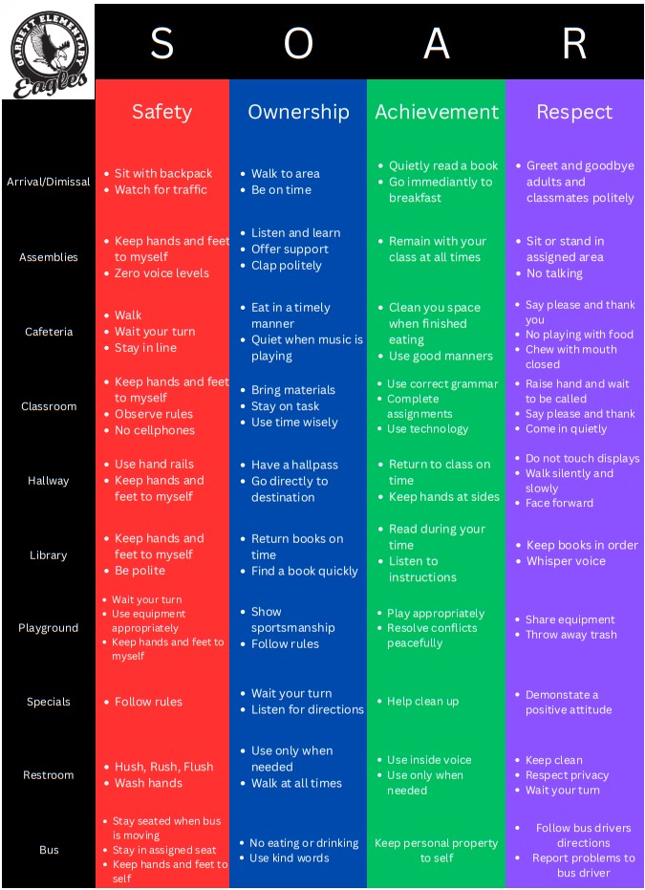

Ron Clarke Academy House System
In addition to PBIS, this year, Garrett Elementary School will be implementing the RCA House system in which the entire school is divided into 4 teams. Each team works together to accomplish various goals. We will engage in a little healthy competition concerning good behavior, morals and ethics. Although we have 4 different teams, we are “4 teams but one family”.



RESPONSIBILITY FOR PROPERTY

Students are personally responsible for textbooks, library books, instructional materials, and desks assigned to them. Students must pay for any damages. Assessment of damage will be determined by the school administration. However, elementary school students who fail or refuse to pay for lost or damaged textbooks, library books, or media materials at the replacement cost shall be refused additional textbooks, library books, or media materials and will have their report cards, diplomas, certificates, etc. held until the restitution has been paid in full. School Property: Parents will be billed and held liable for property that is damaged by students during the school year. A bill will be calculated by the Maintenance Department and provided by the school, payment is expected upon receipt.

Lost and Found
Items that have been found at school should be placed in the Lost & Found boxes located in the Cafeteria, behind the stage. Lost articles can be claimed by properly identifying the lost item. We recommend that parents label all personal items with the student’s name, so they can be quickly identified and returned to the owner without delay. All unclaimed items will be donated to a charitable organization or discarded.

CELL PHONES, PAGERS & OTHER ELECTRONIC DEVICES
A new cell phone policy has been adopted per the Richmond County School System. The policy will
be followed and consequences enforced written. Cell phone use is not permitted on campus at Belair
Elementary School. If a student has been instructed to carry a cell phone by a parent/guardian, it
should remain off and, in the student’s, bookbag during school hours and on campus. A student will
be subject to disciplinary action per the cell phone policy and Code of Conduct, including, but not
limited to, in-school suspension, out-of-school suspension, or expulsion, if the student utilizes a
pager, cell phone or other electronic device to engage in inappropriate use of technology. The
following are some examples of inappropriate use of technology:
• bullying, threats or intimidation, or harassment of any form, o to create and/or send and/or receive and/or possess and/or transmit to others pornographic or obscene pictures or messages to create and/or send and/or receive and/or possess and/or transmit to others offensive or humiliating or inappropriate pictures of one’s self or others,
• Engaging in academic cheating in any form
• Invading anyone’s privacy in a locker room, restroom or other place on a school campus or at a
school activity

It is imperative that we consider the safety of all students and minimize issues with cell phones during school hours. If a student must have a cell phone or electronic device it should be in the student’s bookbag and powered off during the instructional day. If a student uses a cell phone or other electronic device of this nature at school, during the instructional day, or in a manner that is disrespectful or disruptive while on campus, on the bus, the device will be taken from him/her, and turned in to the office with a note containing the student’s name, date, time and teacher’s name. The device will be held in the Principal’s Office until a parent has been contacted and comes to the school to retrieve the device. Second offenses will result in the device being kept for a period of 30 days or as stated in the new RCBOE policy/code of conduct. Upon the third offense, additional disciplinary consequences will apply and the device will be kept for the remainder of the semester or school year (or as stated in the new policy/Code of Conduct). Parents please be assured that all teachers have access to a class phone, an emergency badge to alert administration and the authorities in the event of emergencies. Each grade level has access to a radio, each teacher’s lounge has a phone, and there are several phones in the front office. Please refer to the RCSS BYOT Policy/Cell Phone Policy/Code of Conduct for more information on technology use on RCSS school property.

GRADING POLICY

Students in Grades K-5 are required to perform academically as well as on grade level in all content area classes. Effective July 1, 2022, the new IHA-R Grading Policy will be in effect. There will be 2 grading periods annually, grading period 1- first semester and grading period 2- second semester. Students will receive two progress reports and 1 report card during each semester of school; for a total of 4 progress reports and 2 report cards annually. Please be sure to setup your parent portal account before or during Registration/Open House and monitor grades regularly.

Standards Based Report Card for Grades K-3
The purpose of the new reporting system is to provide parents, teachers and students with more accurate information about students' progress toward mastering standards. On a standards-based report card, each of the subject areas is divided into a list of standards/learning targets/skills and knowledge indicators, that students are learning. This provides concrete understanding of exactly what students know. Progress is measured as follows:

Report cards for grades K-3 will include an academic performance level of 1-4 or P.
1 – Beginning Learner/Not Met: knowledge of the standard has not been demonstrated.
2 – Developing Learner/Meets: some knowledge of the standard has been demonstrated.
3 – Proficient Learner/Meets: adequate knowledge of the standard has been demonstrated.
4 – Distinguished Learner/Exceed: knowledge beyond the standard has been demonstrated.
P- Pass: The student has passed this class. (example: Art, Music, etc).
If an indicator is not measured during the grading period, the student will NOT receive a mark on the report card.

Traditional Report Cards & Grading System for Grades 4 – 5

A = 90-100 B = 80-89 C = 75-79 D = 70-74 F = Below 70

Progress Reports, Report Cards and Grade Reports
Progress reports and report cards will be issued throughout the school year. Refer to the
Academic calendar for release dates. A parent/guardian’s signature is required before report cards jackets are returned to the child’s homeroom teacher.

Graded assignments may be sent home weekly. Parents/guardians are asked to examine, sign and return the papers to the child’s teacher(s) the following day. Parents should contact the child’s teacher or the School Office immediately if questions or concerns should arise.

Homework
Teachers may assign homework daily. In the event your child doesn’t have homework, he/she should read at least 30 minutes, practice sight words, spelling words, and/or vocabulary words, strengthen basic math fluency (addition, subtraction, and multiplication facts), and/or review material from the day’s lessons.

The purpose of homework is to reinforce what the students are learning each day, instill a sense of responsibility, and involve parents in the learning process. Thus, it is very important for parents to work with students to complete the assigned homework and/or practice daily.

Homework may appear in a variety of forms. It may be written assignments or other activities such as listening, reading, watching a TV program, conducting research, playing an educational game, or routine studying. Homework will not exceed the student's ability to complete in a reasonable amount of time.

Extra Credit
Occasionally a teacher may offer the opportunity for a student to earn extra points or extra credit; however, this is not general practice at this school.

PROMOTION, PLACEMENT AND RETENTION POLICY

ELEMENTARY (K-5)
A student shall be promoted when, in the professional judgment of the teacher/s and the principal and other professional school staff, he/she has successfully mastered the identified instructional standards of Georgia Public Schools (K-5) and Richmond County Board of Education.

State Promotion Requirements

• No third grade student shall be promoted to the fourth grade that does not achieve grade level on the state-adopted assessment and meet the local promotion standards and criteria established by The Richmond County Board of Education.
• No fifth grade student shall be promoted to the sixth grade that does not achieve grade level on the state-adopted assessment and meet the local promotion standards and criteria established by The
Richmond County Board of Education.

Additional Richmond County Promotion Requirements Kindergarten
To meet promotion requirements, a student must master essential standards for Language Arts and essential standards for Mathematics as identified on the Richmond County Board of Education report card.

Grades First through Third
To meet promotion requirements, a student must master essential standards for Language Arts, Math, Science, Health and Social Studies as identified on the Richmond County Board of Education report card.

Grades Fourth and Fifth
In addition to State Promotion Requirements in grades third and fifth, students in grades first -fifth must:
a) Obtain a passing grade on the report card in Mathematics and Language Arts; and b) Obtain a passing grade on the report card in two of the following: Social Studies, Science and/or Health.

Communication for Grades K-8
If a student is not meeting the above requirements, the parent/guardian will be notified in the following manner:

1. Midway through the first nine weeks of school (4 1⁄2 weeks of instruction): A parent conference may be held to discuss strengths and weaknesses and offer suggestions for student improvement. A parent conference shall be scheduled to develop an educational plan for each student experiencing difficulties.

2. End of grading period 1 (18 weeks of instruction): At the end of grading period 1, the report card and the report card envelope will indicate with a check mark when the student is not making satisfactory progress toward promotion. The report card envelope will also indicate promotion difficulties. A parent conference shall be held for each student not making satisfactory progress toward promotion.

3. Midway through grading period 2 (27 weeks of instruction): At the end of grading period 2, the progress report will indicate with a check mark when the student is not making satisfactory progress toward promotion, and may indicate promotion difficulties. A parent may request a parent-teacher conference, to evaluate student progress in order to determine improvement needed to meet promotion requirements.
4. End of grading period 2 (36 weeks of instruction): A Conference must be scheduled for all students who are not meeting promotion requirements. The parent/guardian of a student who has been retained will be notified in the final report card.

In addition to the communication described here, when a student does not perform at grade level in grades levels 3, 5, and 8 on the state adopted assessment (s) specified above the school system will also follow communication guidelines and procedures outlined by the Promotion, Placement and Retention State Rule 160-4-2.11 adopted November 6, 2014 and effective November 27, 2014.

ACADEMIC DISHONESTY
Coursework submitted by a student must be the student’s own, original work. Students shall not cheat on any assignment by giving or receiving unauthorized assistance (parents completing assignments for students etc.), or commit the act of plagiarism. Students who commit such acts are subject to receiving a grade of zero on the assignment in question as well as disciplinary action. Complete information regarding academic dishonesty can be found in the RCSS Code of Conduct.

STATE, STANDARDIZED and DISTRICT TESTING
State mandates require student participation in a wide array of assessments. The purpose of the testing program includes monitoring student progress, assessing program effectiveness, planning for instructional improvement, and making placement decisions for special programming. Several of the assessments are utilized as part of the system’s promotion/retention policy. The following specific tests will be administered at Garrett Elementary School:

Kindergarten: GKIDS, i-Ready diagnostics and progress monitoring
Grade 1: Content Mastery Assessments & i-Ready diagnostics and progress monitoring
Grade 2: Content Mastery Assessments & i-Ready diagnostics and progress monitoring, and CogAT
Grade 3: Content Mastery Assessments, i-Ready diagnostics and progress monitoring, GMAS
Grade 4: Content Mastery Assessments, i-Ready diagnostics and progress monitoring, GMAS
Grade 5: Content Mastery Assessments, i-Ready diagnostics and progress monitoring, and GMAS.

The state assessment program requires that students in kindergarten take GKIDS and students in Grades 3-5 will take the Georgia Milestones Assessment (GMAS). Individual test results will be provided to parents as soon as possible after the results are returned to the school. GA Milestones results will be used to guide and direct us in our instructional planning and a part of the Richmond County School System’s Promotion/Retention policy. Students in grades 1-5 will take local benchmark assessments. The CogAT assessments provides information about how students learn and think.

The school Principal or Assistant Principal(s) shall annually notify parents or guardians that placement or promotion of a student into a grade, class, or program will be based on the academic achievement of the student via several data sources to include GMAS, i-Ready, Grades, etc.

Honors Program and Awards

Winter Honors Day August – December

- i-Ready Growth Grades K-5

- Character Kids Grades Pre K-5

- Perfect Attendance Pre K-5

- A honor roll 4-5

- A/B Honor Roll 4-5

- Most Improved for 1st and 2nd 9 weeks. One for behavior and one for academics.

- Books Read for Myon

______________________________________________________________________________

Spring Honor’s Day Information

Listed below are the Honors and Awards for Honor’s Day:

- T. Harry Garrett Award: Top boy and girl in every class with good academic performance and good character. (Grades 1 – 5)

- A Honor Roll: All A’s or S’s in all subjects. (Grades 4 – 5)

- A/B Honor Roll: All A’s and B’s in all subjects. (Grades 4 – 5)

- Highest Academic Average: Top two students from each class with the highest academic averages (e.g. valedictorian and salutatorian. (Grades 4 – 5)

- Most Improved: The two children in each class that have shown the most improvement: one for behavior and one for academics. (Grades 1- 5)

- Citizenship: Two children from each class who are well rounded, cooperative, show concern for fellow students and the teacher, and has pride in the class and school. (Grades 1 – 5)

- Perfect Attendance: Student has been present every day and has less than 10 tardies and/or early releases. (PreK – 5th Grade)

- Perfect Presence: Students have been present every day and has 0 tardies. (PreK – 5th Grade)

- Character Kid: Any child that has been recognized as a character kid throughout the school year. (PreK – 5th Grade)

- Science Fair Participation: This award recognizes the children that participated in the science fair. (Grades 3 – 5)

- Math Team: This award recognizes the student that participated in this year’s math competition. (Grades 4 – 5)

- Drill Team: Any student that has participated all year in drill team. (Grades 3 – 5)

- 4H and CHAMPS: All students who participated in 4H and CHAMPS. (5th Grade)

- Art: The top boy and girl of each grade that have shown exceptional behavior, talent, attitude, and have an average of 95 or above in Art. (Pre-K – 5th Grade)

- Dance/Drama: The top boy and girl of each grade that have shown exceptional behavior, talent, attitude, and have an average of 95 or above in Dance/Drama. (Pre-K – 5th Grade)

- Music: The top 2 students of each grade that have shown exceptional behavior, talent, attitude, and have an average of 95 or above in Music. (Pre-K – 5th Grade)

- Physical Education: The top two students in each grade level who have shown exceptional skill and talent in Physical Education.

Volunteers & Visitors

Volunteers are an invaluable asset in helping to meet the needs of students and staff. However, it is
imperative that faculty and staff know who is present in the building and possibly around students at all times, and that we always maximize and not interfere with instructional time. All volunteers and visitors must report to the Front Office upon entering the building. If you would like to visit your child’s classroom, please give us a 24-hour notice. If your visit is related to checking on your child for discipline concerns, please see the Principal. While we welcome visitors, the regular school program must continue, so please do not place demands on teachers for conferences, etc. during instructional time.

Parent volunteers are needed. Those who are able to help are asked to contact the school office. All volunteers in the school are required to attend a training workshop provided by the county or school. All volunteers will also be submitted to criminal background checks. Trainings are held prior to PTO Meetings. Adults without a current approved volunteer status cannot supervise school events, school field trips or class activities.

By action of the 2012 Georgia General Assembly, all school volunteers in Georgia are now "mandated reporters" of suspected child abuse. [O.C.G.A. Section 19-7-5]. Therefore, if by direct observation, a verbal/written communication, or by some other means you become aware or form a reasonable suspicion that a child has been abused either at school or at home, you must report this information to the principal. Once you have reported your knowledge, it then becomes the responsibility of the administrator to report the suspected child abuse to the appropriate state or local investigative agency.

ENTRANCE TO PRE-K, KINDERGARTEN AND FIRST GRADE

All Pre-K, Kindergarten and first grade students must present a certified (with seal) copy of their birth certificate before entering school for the first time. The school will accept a certified copy issued by the local Department of Health in the county where the child was born. If you cannot obtain a birth certificate from the local department of Health (for a child born in Georgia), you can send the child’s full name, date, and place of birth, father’s full name and mother’s full maiden name along with a U.S. Postal money order for $10.00 (fee required for the search) to:

Georgia Department of Human Resources
Vital Records Services
Room 217 H
47 Trinity Ave. S.W.
Atlanta, GA 30334

Beginning school year 2007 – 2008, if your child is under five (5) years of age, he/she must have protection against the pneumococcal disease. He/she will need the Pneumococcal Conjugate Vaccine (PVC). The number of doses needed will depend on the child’s age. In addition, if your child is currently enrolled in four (4) year old pre-k program, he/she may need to obtain the 2nd dose of varicella and mumps vaccines and will need to submit documentation of meeting the new requirement on the Georgia Certificate of Immunization (Form #3231) upon entry into five (5) year old kindergarten.

Effective with the 2000 – 2001 school year, for entrance into any Georgia Public School, all students must have completed the Hepatitis B Vaccine Series. For entrance in to the sixth grade, or at its equivalent age, each child must show proof of one additional dose of MMR Vaccine, for a total of two MMR vaccines administered on or after the child’s first birthday and at least thirty days apart. A waiver of up to 30 days (90 days for children arriving from outside the state of Georgia) may be granted the responsible official of any school if, in his/her opinion, a deferment of the certification requirement is justifiable.

In addition to the certified birth certificate, parents of Pre-K, Kindergarten and First grade student must provide and eye, ear, and dental examination form, and an up-to-date immunization form with the varicella vaccination or date. These records must be on Georgia forms. The school also needs each student’s Social Security number.

AGE REQUIREMENTS
A student entering Pre-K must be four years of age on or before September 1.
A student entering Kindergarten must be five years of age on or before September 1.
A student entering First Grade must be six years of age on or before September 1.

MOMENT OF SILENT REFLECTION

In compliance with Georgia law, all teachers at public schools will conduct a moment of reflection that lasts 60 seconds at the beginning of each school day. According to this law, this moment of quiet reflection is not intended to be a religious observance or exercise. It is an opportunity for reflecting on the anticipated activities of the day.

Lunch

We urge you to encourage your child to eat in the school lunchroom. Most of our students eat a well-balanced breakfast and lunch. Students may bring lunch, if desired. Students may bring a thermos, but beverages in cans or bottles are prohibited in the lunchroom. Fast food from outside restaurants may not be brought into the lunchroom in restaurant wrappers or bags/containers. This is School Food Service Policy.

If you have any questions or concerns, please contact Nutrition Manager at 737-7222 ext. 1714

DISCIPLINARY ACTIONS

The majority of student discipline is handled at the classroom level by the teacher or adult in charge. Continual misbehavior or incidents that require immediate attention may be handled by the principal. Student discipline is tracked to note tendencies and patterns or misbehavior. The action taken on an incident is based upon the severity of the incident and the student’s past history. Consistency and fairness are important aspects of dealing with student discipline. As a student begins to compile a large number of incidents, teachers will be expected to implement a BIP (Behavior Intervention Plan) for the student, along with an RTI. Parents/Guardians will be informed of all major discipline incidents that reach the Principal’s office through the use of the discipline referral form. Discipline information is also sent with school records when students withdraw.

PARENT – TEACHER CONFERENCES

Most academic and discipline problems can be solved through a steady stream of communication between teacher and parent. Parent - teacher conferences are expected to take place at least twice a year, October/March respectively. Professional educators need time to prepare for these and other meetings so please arrange these meetings in advance. Note: Avoid Tuesdays as those days are used for collaborative planning during the school day and Thursdays as those are used for Faculty meetings after school. If you need to speak to a teacher, please contact the teacher or call the school and leave a message. The teacher will return your call as soon as possible, most likely by the end of the day.
SAFETY

Safety is a prime concern at Garrett Elementary School. The school safety plan is updated annually and addresses everyday safety as well as emergency situations. We will conduct a fire drill each month, a tornado/sever weather drills once during the school year, along with public safety alerts and hard lock down drills. Garrett also has a ‘buzz-in’ video-viewed door system as an extra layer of protection for our students and staff.

In the front area by administration offices, we have doors that are accessed with a badge or by the front office staff. We also have doors at the entrance to the 2nd floor.

We ask parents to support our efforts to provide a safe environment by reinforcing school rules with their children regarding behavior at school, on busses, and walking to and from school.

Students will be closely supervised while on the school campus between 7:00 a.m. and 2:30 p.m.

Follow safe drop off and pick up procedures for students in designated areas.

Faculty members and Richmond County Board of Education Public Safety officers on duty stations at arrival/dismissal in automobile and bus loading zones are there to assist parents and to enforce school safety rules. Students must remain with the teacher until their ride comes to the loading zone.

Caution your child to be careful when crossing streets and to cooperate with the crossing guard.

PROGRESS REPORT/REPORT CARD REPORTING CYCLE

Teachers should enter grades in the Infinite Campus gradebook on a weekly basis throughout the semester. This allows students and parents/guardians to have continuous access to current student grades.

Each semester represents an 18-week grading period.
- Progress Report 1 will be issued at the end of the first 6-weeks.
- Progress Report 2 will be issued at the end of 12-weeks.
- Semester Report Card will be issued at the end of the 18-week grading period.

This process will occur again for the second semester.

Each progress report will reflect the student’s cumulative achievement (The result of all grades since the first day of the semester.)

The student’s final grade will reflect their cumulative achievement from the first day to the last day of the semester.

This process allows teachers to evaluate the student’s progress toward mastery of the standards based on the full body of evidence from the entire semester.

TRANSFERRING

It will become necessary for some of you to leave our school during the year. Please notify your teacher and the office at least 24 hours in advance, so that we may help make your transfer prompt and efficient. Library books and textbooks must be turned in before leaving. Please do not ask your child to relay the message of withdrawal. Either phone the office or write a note to the teacher.

HOSPITAL-HOMEBOUND INSTRUCTION

Students who will be absent from school for a significant length of time due to illness may be eligible to participate in the Hospital-Homebound Instructional Program. For more information, please call Student Services at 706- 826-1129.

INCLEMENT WEATHER

In the event of inclement weather conditions, parents are encouraged to listen to local media for the superintendent’s decision to close or delay the opening of school. Parents are urged to keep telephone numbers current and updated, since notification of early school dismissal is transmitted by Infinite Campus.

LIBRARY

The library is available to every student in the school. The library will be open from 7:00 a.m. until 1:30 p.m. Books should be returned promptly. The rule for lost or damaged library books is the same as for textbooks.

RETURNED CHECK POLICY

Due to the excessive number of returned checks in the past, the fee for a returned check written to the school will cost $30.00 for our check recovery system.

SIGNING STUDENTS OUT EARLY

No person other than a parent or legal guardian may sign a child out early from school, except by presenting a writing permission note from a parent or guardian to the office. The office should be notified of any child who is not to be picked up anyone other than a parent or guardian. Parents are requested to list persons with permission at the bottom of the registration card. Otherwise, a student will NOT be released to anyone that is not on the registration form. No exceptions. Students leaving must be picked up before 1:30 p.m.

TEXTBOOKS

All textbooks are to be covered as soon as possible. Also, please see that the cover stays on for the entire school term. Textbooks are free of charge, but children and parents are held responsible for their proper care and use. Lost books must be paid for before we can issue your child another book. Refunds will be made if the book is found at a later date. Textbooks are full price regardless of the condition when lost. Report cards will be withheld at the end of the year if lost books have not been paid for.
EVACUATION

In case of an emergency where the school must be evacuated, the students will be escorted to the parking lot of the Whole Life Ministries on the corner of Azalea and Washington Road.

LOST AND FOUND

Lost clothing items are placed in a box near the elevator on the first floor. Other items are generally turned in to the office. You are invited to inspect the lost and found an item from time to time in case a lost article has been turned in that belongs to your child. Periodically, lost articles are donated to Goodwill. It may be helpful to put your child’s name in his/her coat.

ILLNESS/MEDICINE

If a child becomes ill at school, we must make home contact in order for the child to be picked up. Our clinic facility is very limited and we have a part-time nurse. No medication will be administered to students unless it is a doctor’s prescription and accompanied with a note giving parental permission for school personnel to administer medication to the child. Students should not be sent to school with a fever, no matter how slight. Parents will be called to pick up a child who has a fever.

PARENT – TEACHER ORGANIZATION

T. Harry Garrett PTO is a very active and viable organization. All parents and friends of the school are urged to join and participate. Garrett PTO supports many school initiatives. In the past, PTA has supported/provided for art/drama supplies, teacher supplies, Honor’s Day rewards, student agendas, school grounds beautification projects, and much more! Our students truly benefit from all of these endeavors. We are very proud of our Garrett PTO!

ACCIDENTS

Minor scrapes and bruises are handled at school. If it is deemed serious enough, a school nurse will examine the student’s injury. Serious cases result in emergency treatments. Be sure to completely fill out the registration card with all telephone numbers, doctors, and information needed in an emergency. In most cases, hospitals will not treat patients without a parent’s signature. We must be able to reach a parent in the case of an emergency that may require hospitalization. Please make sure that your child reports all injuries to staff. Any accident reported at school must have the accident report completed.

EMAIL/TELEPHONE CALLS

Emails are the best way to reach your teacher. However, if you need to call the school, we would be glad to deliver a message to the teacher or have the teacher call you during their planning or after students leave for the day. Note: Students are not allowed to use the school telephone except in emergencies.

HOMEWORK ASSIGNMENTS

Teachers are not required to assign homework. However, when assigned on an as needed basis, homework can be a valuable part of the instructional process. It allows students to practice what has been taught; it lets parents see what students are learning and where they are in their level of understanding; and it gives teachers the opportunity to provide useful feedback to students.

As a general guide:
• Elementary school students should not have more than 15-45 minutes of homework total across all content areas per night, Monday -Thursday

EARLY RELEASE FOR PARENT CONFERENCE DAYS

Garrett Elementary School participates in the Parental Involvement Program of the Richmond County Board of Education. Twice during the school year, parents are invited to meet with the teacher via in person, phone call or Zoom meeting for a conference on specified days with their child’s teacher These will be early release days. Students will be dismissed at 11:30 a.m beginning with Pre K and Pre K siblings. The overall goal of the program is to enable the students to reach their maximum educational potential through:

- Seeking your cooperation as parents in the process of educating your child
- Sharing the methods of tutorial assistance with you; and
- Establishing a positive home/school relationship.

To achieve these objectives, the staff of your child’s school will be contacting you and encouraging you to meet with your child’s teacher via phone call or Zoom platform for conferences about your child’s education. If your child is in danger of failing, you will be requested to attend a conference.

WAYS TO HELP YOUR CHILD FIND SUCCESS IN SCHOOL

Provide a quiet period at home each day for reading and other constructive activities.
Read daily to your child – including your pre-school child.
Listen to your child read. Ask he/she questions that tests their creativity.
Show interest in school activities.
Work with the school by visiting, conferences, and PTA membership.
Give praise and encouragement. Reward them for great work!
Visit the school to observe your child at work.

TESTING

Several tests are administered to students during the school year according to state guidelines. The results of those tests are used by teachers to diagnose students’ needs and to prescribe for those needs. Parents are made aware of their child’s test results with either a printed profile or a conference with the teacher. This year, we will administer the following: CogAT, GKIDS-Kindergarten-, ACCESS for ELLs, GAA 2.0-K and 2-5 and Georgia Milestones – Grades 3-5. Please see the testing calendar on our website or RCBOE for specific dates, tips, and links.

Regulation IHA-R: Grading Systems
- Elementary School

- Academic Grade Reporting: Kindergarten – 3rd Grade
Student performance in Grades K-3 will be recorded and reported by numerical grades on a 4-point, standards-based scale.

- Calculation of Final Grades Final grades will be determined at the end of each semester based on the cumulative body of evidence for each standard. The mode of all assessment scores per standard will be used to identify patterns of performance over time and guide determination of final grades.

Minimum number of assessment scores collected per 6-week progress report = 5

Content Mastery Assessments will be given quarterly in all Grade 3 core content areas.
These assessments will be scored by standard.

B. Academic Grading Scale

4 | Distinguished Learner | Makes applications and inferences beyond expectations
3 | Proficient Learner | Meets standards consistently and independently
2 | Developing Learner | Progressing toward meeting standard
1 | Beginning Learner | Limited progress toward mastery of standards
ND | Not Demonstrated | Not Yet demonstrated
NA | Not Applicable | Not applicable at this time

- Academic Grade Reporting: Grades 4 – 5

Student performance in Grades 4 – 5 will be recorded and reported in all courses by numerical grades based on a 100-point scale.

- Calculation of Final Grade

Final grades will be determined by the cumulative semester average using the following criteria:

    - Minor Grades = 60%: Examples include quizzes, labs, and other graded assignments to assess certain standards in a unit of study.
    - Minimum number of grades per 6-week progress report = 5

    - Major Grades = 40%: Examples included unit tests, essays, research papers, project-based assignments to measure mastery of standards that comprise a unit of study.
    - Minimum number of major grades per 6-week progress report period = 2.

- Academic Grading Scale
A | Represents an average of 90 – 100
B | Represents an average of 80 – 89
C | Represents an average of 79 – 79
D | Represents an average of 70 – 74
F | Represents an average of below 70

ARTS INFUSION PROGRAM

Garrett Elementary has the Arts Infusion Program. Through art, dance, drama, and music, our children have developed socially, emotionally and academically.

REVIEW OF CUMULATIVE RECORDS

The school cumulative record is available for inspection by parents upon request. Parents desiring such a review should call the school office to set up an appointment with the principal or teacher.

LEGAL CUSTODY RIGHTS

Schools need proof of legal custody and visitation rights. In cases where parents are separated or divorced and one parent has legal custody, the school must have proof of the court order that spells out both custody and visitation rights are part of the permanent record. Parents cannot be legally denied access to their children without a copy of a court order specifying “no contact is permitted.” We will, however, work closely with you to ensure your child’s safety and welfare.

EMERGENCY TELEPHONE NUMBERS

Parents must list several different, working telephone numbers for use in case of emergency. Students can be suspended until the school has the necessary means to get in touch with parents. Legal agencies regard this as abandonment.

PROCEDURE FOR ADMINISTERING MEDICINES AND MEDICATIONS

It shall be the policy of the Richmond County Public Schools that all children’s medicine and/or medication be administered by a parent at home. Under exceptional circumstances, medication may be administered by the school principal, his/her designee or the school nurse in compliance with the following administrative. Regulations:

- LONG TERM PRESCRIPTION MEDICINES

- A completed form (see attached form) shall be on file for each child requiring long term medication or medicine. Such form shall include:
- Name of child, address, and phone number
- Name of medicine and medication
- Purpose of medicine and medication
- An official label must be on the container of medicine of medication
- Physician’s requirements specifying frequency (dosage) and method of administration
- Physician’s description of anticipated reactions of child to medicine or medication
- Instruction to school personnel to follow in the event of side effects
- Termination fate for administering medicine or medication or statement that medication is to be given for indefinite period of time
- Parents(s) or legal guardian(s) signature approving the administration of the medicine or medication.
- Long term medication will not be administered to students unless that above conditions are followed.

- SHORT TERM PERSCRIPTION MEDICINES (10 DAYS OF LESS)

- Short term medications should not be given unless a completed form (see attached form) shall be on file for each child requiring medication or medicine or unless the information received in writing by the school contains the following information:
- All medicine must be in its appropriate bottle or container
- Each bottle shall have a label with the name of the students, name of the medicine, doctor’s requirement for how to administer, frequency of dosage, and termination date
- In addition, there shall be a note signed by the parent giving permission for the medicine to be administered and a phone number where the parent could be reached
- All inhalers brought by students shall be considered short term medicine and shall be kept in the office and not in the classroom.

- OVER THE COUNTER MEDICATION

- Before over the counter medication can be administered to students, there must be a signed note from a parent authorizing such administration, setting forth the dosage, the frequency, and termination date.
- All over the counter medicines must be in the original containers with the child’s name taped on to the bottle.
- Such medicines shall be administered by the principal or principal’s designee or school nurse. The principal may designate for over the counter medicines, the classroom teacher or office personnel, depending on what would be appropriate under the circumstances. This applies to over the counter medicines only.

- GENERAL CONDITIONS FOR ADMINISTRATION OF ALL
CLASSIFICATIONS OF MEDICINES, INCLUDING OVER-THE
COUNTER

- The school principal, his designee, or the school nurse shall:

- Inform the classroom teacher of the medicine or medication
- Keep a record of the administration thereof
- Keep the medicine or medication in a securely locked cabinet
- Return unused medicine to the parent only
- Call an ambulance in any emergency situation.
- The parent(s) or legal guardian (s) of the child must assume full
responsibility for informing the school principal or school nurse of any
change in medication.

- SCHOOL SYSTEM’S DISCRETION

The district retains the right to reject requests for administration of medicine
where all of the conditions set forth herein are not met or were, in the
opinion of authorized personnel, the administration of such medicine is not
appropriate for the school. In these cases where it is determined the
appropriation of a particular medicine is not proper for administration, the
Director of Guidance and the Assistant Superintendent for Instructions shall
be notified so that alternative arrangements can be made.

- FORMS REQUIREMENT

The Administration of Medicines/Medication form must be completed and
filed each school year and whenever the prescription is changed by the
physician. A copy of this form shall be filed in the student’s personal folder,
the school nurse’s office and forwarded to the child’s parent.

- POSTING

- A copy of this policy and the administrative regulations shall be posted in all school clinics, made available to the school nurse and the principal, and provided for parents upon the requests for administration of medication in the school.

- The administration of prescription medicine, whether long-term or short-term, shall not be in the classroom; however, for over the counter medicines, if the principal deems it less disruptive or more efficient for it to be administered in the classroom, the principal has the discretion to require the same.

ADMINISTRATION OF MEDICINES/MEDICATION

Child’s Name:____________________________________________ Homeroom:____________

Address:______________________________________________________________________

Name of Medication:____________________________________________________________

Purpose of Medication:___________________________________________________________

______________________________________________________________________________
Physician’s requirements of dosage and method of administration:________________________

_____________________________________________________________________________

______________________________________________________________________________

______________________________________________________________________________

______________________________________________________________________________

What to do in case of side effects:__________________________________________________
_____________________________________________________________________________
_____________________________________________________________________________

Termination date for administering the medication_____________________________________
_____________________________________________________________________________
_____________________________________________________________________________

_____________________________ ______________________________
Date Physician’s signature

_____________________________ ______________________________
Date Parent’s signature

Approved by:

_____________________________ ______________________________
Principal Date

Title I

Garrett Elementary is a Title 1 school.

Title I, Part A of the Elementary and Secondary Education Act of 1965 (ESEA) significantly
raises expectations for states, local educational agencies (LEAs), and schools in that all students will
meet or exceed state standards in reading and mathematics within twelve years of the signing of the
law. On July 5, 2002, the U.S. Department of Education (US ED) issued final regulations, effective
August 5, 2002, regarding Title I provisions relating to standards and assessments. On November 26,
2002, the US ED released final regulations with respect to the definition of adequate yearly progress
(AYP) and other aspects of the ESEA. In November 2011, Georgia submitted a waiver request to US
ED for ESEA Flexibility. The waiver request was made in order to strengthen accountability by
replacing current AYP calculations to reflect the definitions of Priority, Focus, Alert, and Reward
Schools. This will allow Georgia to increase emphasis on the State’s very lowest performing Title I
schools in all subject areas and highlight subgroup achievement gaps. This plan will serve to increase
the quality of instruction in all subject areas for all students and define a system that will support
continual improvement of student achievement.
Georgia’s ESEA Flexibility Waiver allows Georgia to develop and refine the next generation of
accountability known as the College and Career Readiness Performance Index (CCRPI) which will
serve as a companion statewide communication and accountability tool for school improvement.
Under this new accountability system, Georgia will identify Title I Reward, Priority, and Focus
Schools as prescribed by US ED using data from state assessments. Alert Schools, unique to Georgia,
will also be identified based on graduation rate alerts for high schools or subgroup and subject alerts
for middle and elementary schools. Alert Schools will include both Title I and non-Title I schools.
In addition, all state assessments along with other indicators of success will be used to calculate every
school’s CCRPI overall score. The 2011-2012 school year will serve as a study and refinement year
for the CCRPI. The calculations related to the CCRPI are separate from the US ED required
methodology for identifying Title I Priority, Focus, Alert, and Reward Schools.
Several other provisions of ESEA impact Georgia schools. Teachers and paraprofessionals must be
highly qualified as defined in the statute and regulations. Teachers may not teach subjects for which
they are not qualified. Also, schools must use programs and materials that have been proven to
provide achievement results for similar populations.
ESEA has a strong focus on parental notification and involvement and, under some circumstances,
gives parents choices regarding their children’s education. This massive piece of Federal legislation
provides accountability for schools and LEAs to ensure that all children are educated to standard levels
of proficiency.
Guidance C-6 is for advising parents of the Right to Know Information about a Teacher’s Qualifications as Required by the Elementary and Secondary Education Assistance Act of 1965 (ESEA) [Section 111(6) (A)]

Dear Parent(s)/Legal Guardian(s):

As a Title I school, we must meet federal regulations related to teacher qualifications as defined in The Elementary and Secondary Education Assistance Act (ESEA). These regulations allow you to learn more about your child’s teachers’ training and credentials. We are happy to provide this information to you at any time, you may ask:

• Whether the teacher met state qualifications and certification requirements for the grade level and subject he/she is teaching,
• Whether the teacher received an emergency or conditional certificate through which state qualifications were waived, and
• What undergraduate or graduate degrees the teachers hold, including graduate certificates and additional degrees, and major(s) or area(s) of concentration.

You may also ask whether your child receives help from a paraprofessional. If your child receives this assistance, we can provide you with information about the paraprofessional’s qualifications.

Our staff is committed to helping your child develop the academic knowledge and critical thinking he/she needs to succeed in school and beyond. This commitment includes making sure that all of our teachers and paraprofessionals are highly skilled.

If you have any questions about your child’s assignment to a teacher or paraprofessional, please contact Ms. Stacey M. Walk at Garrett Elementary School at 706-737-7222 or email
Ms. Stacey M. Walk at walkst@boe.richmond.k12.ga.us.

CHILD ABUSE/NEGLECT

It is a felony for school officials to fail a report suspected child abuse to the proper authorities. Our school will report all suspected child abuse and neglect.

Richmond County Board of Education
Program for the Gifted

Richmond County provides programs for all system students in grades K-12 who exhibit superior performance, advanced learning needs and demonstrate higher-level motivation and creativity. The identification proves uses multiple criteria as mandated by the Georgia Department of Education.

ACE-Academic and Creative Enrichment (Grades K-8)

Students are enrolled in a resource program and are served five (5) hours per week. Mini-units integrating the academic areas form the basis of the curriculum. Units for each grade level include the skills areas basic to Gifted Education.

I. Developing Cognitive skills
II. Learning Skill
III. Research and Reference Skills
IV. Communication Skills

All units are based on Bloom’s Taxonomy of Education Objectives and The Multiple Intelligences.

Placement of Students

All students placed in the Richmond County Gifted Program must meet the mandated Georgia Department of Education eligibility requirements. Referrals are solicited from all system schools twice annually for testing of students. Students may be referred by parents, peers, school personnel and self.

Students entering the system who had prior placement in a gifted program will be placed at once if they meet Georgia Department of Education eligibility. Gifted Program staff will evaluate those who do not have the required eligibility documentation.

Gifted Program Referral Process

Parents, Teachers, Counselors, or Administrators may refer a student in grades K - 5
Review Data ( iReady, PSAT, CogAT, Milestones-SLDS, etc.)
Create an Academic Profile for each student you are planning to refer.
Obtain Gifted Nomination & Gifted Referral Forms from Gifted Liaison to complete.
Submit Academic Profile and completed Referral Form (for students who will be referred)

Data to Consider

Georgia Milestones Scores (Math and Reading)
iReady
Panorama Survey Data
Summative Assessments

For further information, contact your child’s school or the Gifted Program Consultant at (706) 826-1010 Ext. 5664.

Notice of Nondiscrimination

The Richmond County Board of Education does not discriminate on the basic or race, color, national origin, religion, sex, disability or age in its programs and activities. The following person has been designated to investigate any complaint communicated to the Board of Education alleging non-compliance of non-discrimination policies.

Assistant Superintendent for Administrative Services
County Board of Education of Richmond County
864 Broad Street
Augusta, GA 30901
Telephone (706) 826-1000

